NIST SP 800-82 Compliance for Log360
Protect critical infrastructure and meet NIST SP 800-82 compliance with Log360.
Region: USA | Type: Critical Infrastructure, Industry Standard, Incident Management | Category: Compliance | Pricing: Free

Overview
The NIST SP 800-82 compliance extension in Log360 helps organizations meet NIST Special Publication 800-82 Rev. 3, NIST's guide for securing operational technology environments including SCADA, DCS, and PLC systems, applicable to asset owners and operators of industrial control systems by providing centralized log collection, cross-platform security monitoring, and real-time threat detection. The platform supports NIST SP 800-82 requirements for OT access control, audit and accountability, configuration management, network and system protection, system integrity monitoring, incident response, and risk assessment.
For OT Access Control and Authentication, Log360 monitors AD, Windows, Unix, and network device logon events to enforce least-privilege access and accountability in OT environments. To address OT Audit and Accountability, the platform centralizes EventLog, system event, GPO, database audit, and user activity records to maintain comprehensive OT audit trails. The extension also supports OT Configuration Management by providing capabilities that monitors network device configurations, policy changes, Windows registry changes, and software update events across OT environments.

Key Features
- OT Network and System Protection: Log360 monitors network device rules, firewall security events, network attack reports, and policy management to enforce OT network boundaries.
- OT System Integrity and Threat Detection: Log360 aggregates antivirus, threat detection, registry change, and process tracking reports to identify OT integrity violations.
- OT Incident Response: Log360 correlates threat intelligence from FireEye, Trend Micro, network attack reports, and antivirus alerts to support rapid OT incident response.
- OT Risk Mitigation: Log360 centralizes vulnerability data and maps it against current threat intelligence, enabling security teams to focus remediation efforts on the most critical risks impacting the availability and integrity of OT operations.
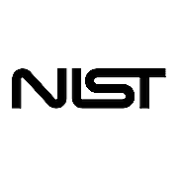
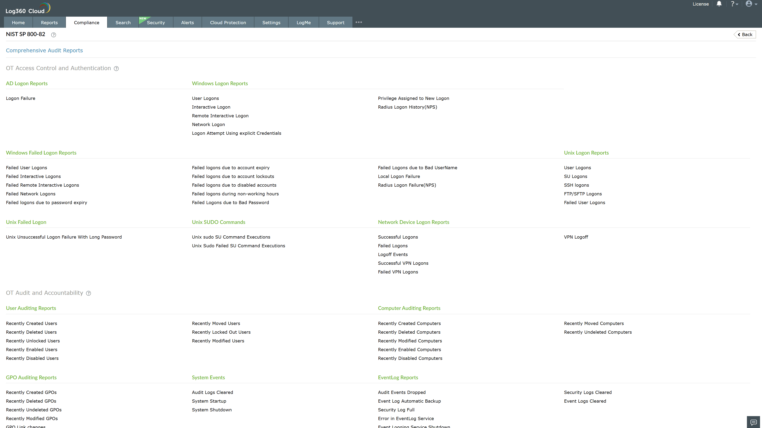
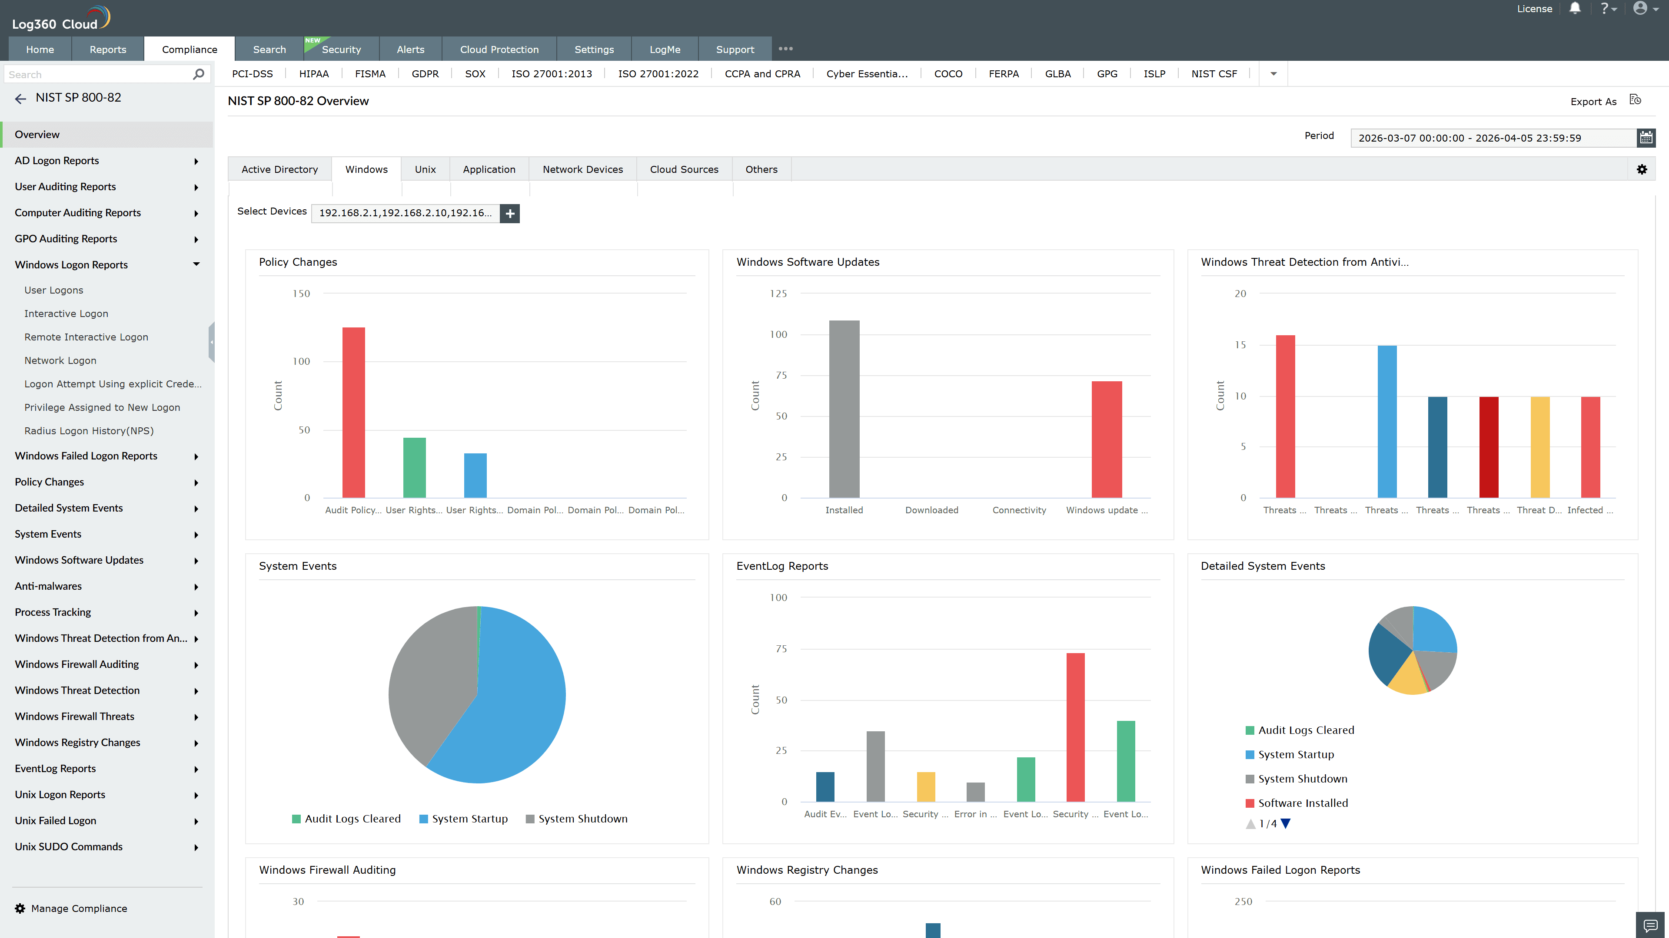
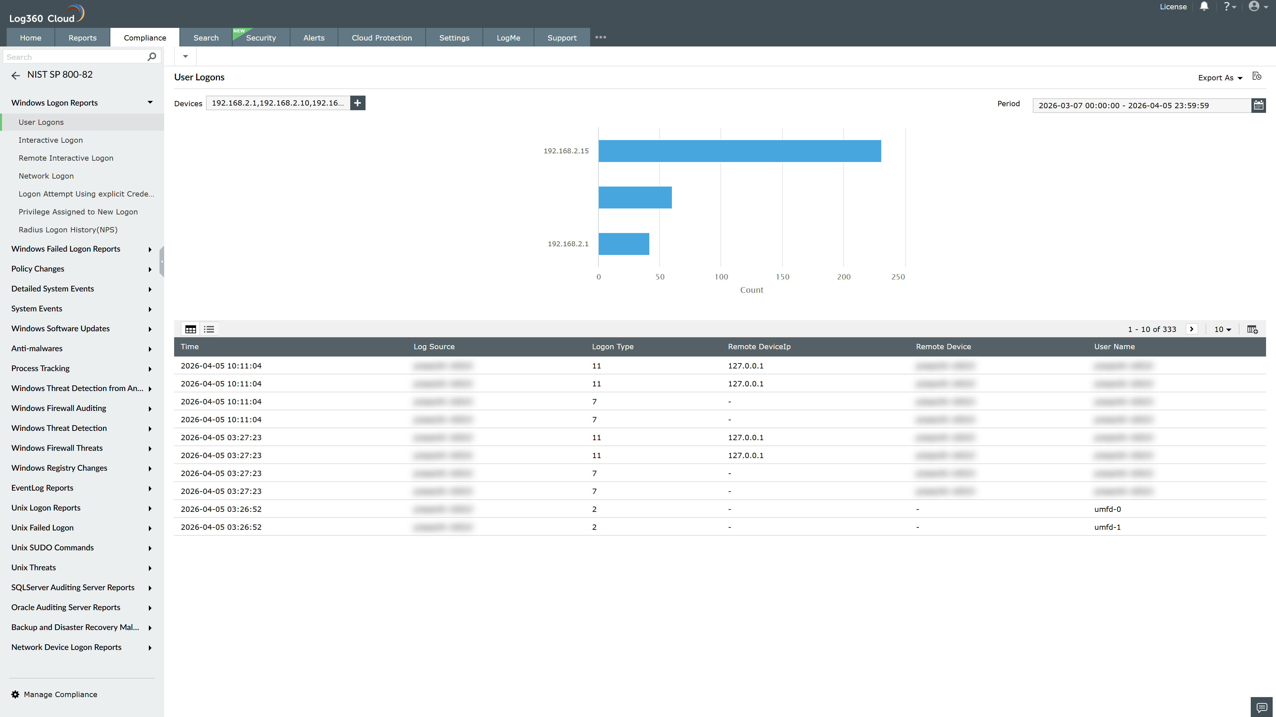
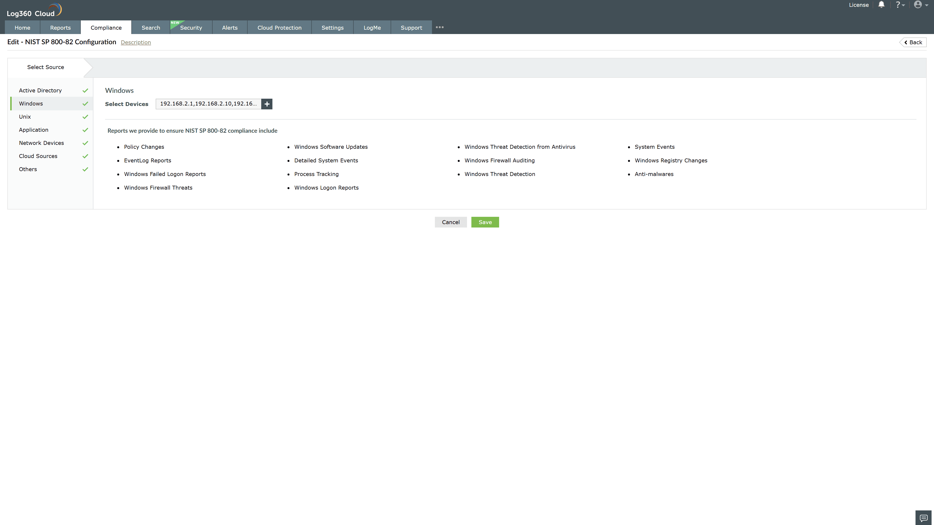
Valid Submission : Yes
Supported Editions : Free, Basic, Standard, Professional, MSSP
Help Document : https://www.manageengine.com/log-management/help/integrations/compliance-extensions.html
Help Video : Not provided
Tags : Log360, Compliance, Privacy monitoring, Data privacy, Regulatory compliance
Supported DCs : US, IN, JP, CA, AU, UK and EU
Privacy Policy:
Terms of Service:
Release Notes:
Predefined reports for the NIST SP 800-82.

